**New York University Tandon School of Engineering**

Biomedical Engineering

Applied Mathematics and Statistics for Biomedical Engineering

Fall 2021

Professor Mirella Altoe

Tuesday 5:00-7:30PM Rogers Hall 325

**Computer Lab Assignment #8**

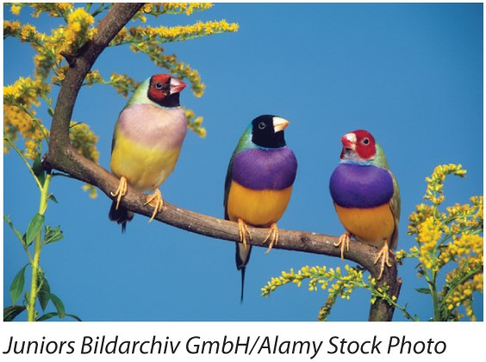**QUESTION 1:** In a study of the *Gouldian finch*, Griffith et al. (2011) looked at stress caused by having an incompatible mate. There are two genetically distinct types of *Gouldian finches*, one having a red face and the other having a black face. Previous experiments have shown that female finches have a strong preference for mating with males with the same face color as themselves, and that when different face types of finch mate with one another, their offspring are less likely to survive than when both parents are the same type. Researchers paired females sequentially with males of both types in random order. In other words, each female bred twice, once with a compatible male and once with an incompatible male. Each time, females produced a brood of young with the assigned male. For each pairing, the researchers measured the blood corticosterone concentration (in units of ng/ml) as an index of the amount of stress the females experienced. The corticosterone data for 43 females are given in the accompanying table. Data available online. [**Data available online.**](https://whitlockschluter3e.zoology.ubc.ca/Data/chapter13/chap13q20StressAndIncompatibleMates.csv)

1. **(1.0 pt.)** Plot the distribution of differences in stress levels between females with compatible and incompatible mates. What trend is suggested?

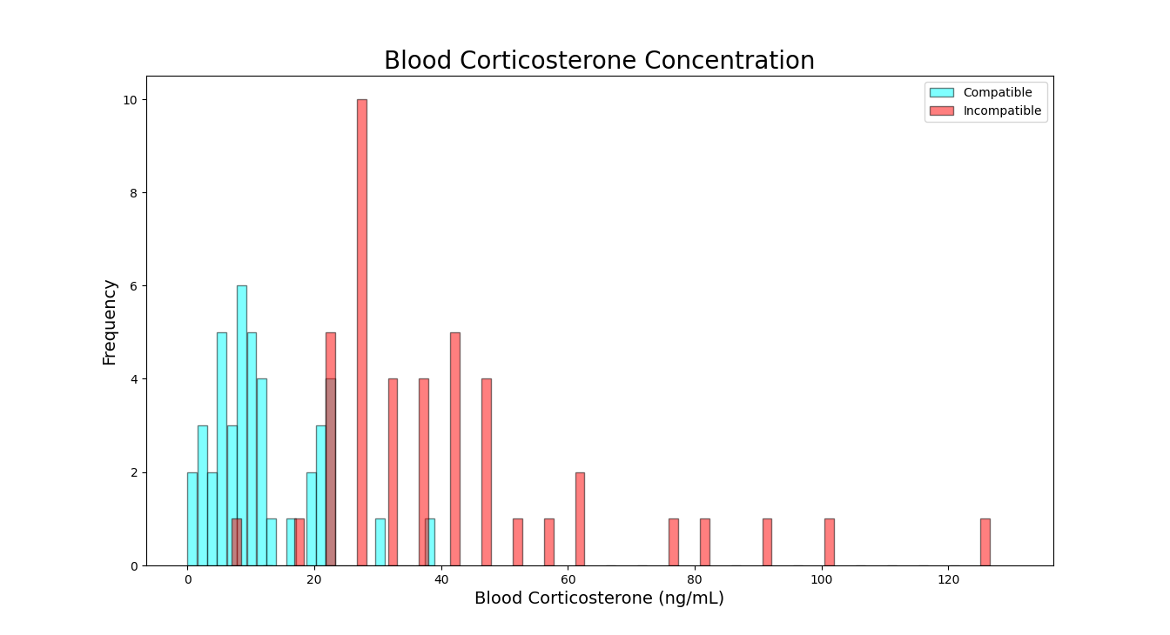

The histogram suggests a right skew to both groups.

1. **(1.0 pt.) If we wished to carry out a test of the difference between treatment means, would a paired t-test be appropriate for these data? Why or why not? Would a sign test be appropriate for these data? Why or why not?**

A paired t-test would be appropriate for this dataset because each female birds bred with a compatible male and an incompatible male (twice in total). A sign test would be appropriate for this dataset since both groups are not normally distributed.

**QUESTION 2:** **(2.0 pts.)** When intruding male lions take over a pride of females, they often kill most or all of the infants in the group. This reduces the time until the females are again sexually receptive. This infanticide has many consequences for the biology of lions. It may be the reason,

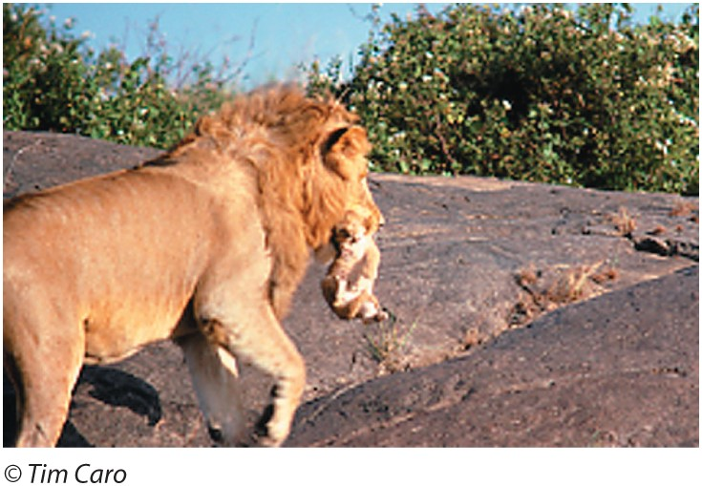for example, that female lions band together in groups in the first place (to be better able to repel invading males). The period after the takeover of a pride by a new group of males is an uncertain time, when the stability of the pride is unpredictable. As a result, we might predict that females will delay ovulation until this uncertainty has passed. A longterm project working on the lions of Serengeti, Tanzania, measured the time to reproduction of female lions after losing cubs to infanticide and compared this to the time to reproduction of females that had lost their cubs to accidents (Packer and Pusey 1983). The data are given below in days. Does infanticide lead to a different distribution of the delay to reproduction in females than when cubs die from other causes? The data are not normally distributed within groups, and we have been unable to find a transformation that makes them normal. Perform an appropriate statistical test.

**Accidental death (same lion):** 110 , 117 , 133 , 135 , 140 , 168 , 171 , 238 , 255

**Infanticide (intruding new male lion):** 211 , 232 , 246 , 251 , 275



